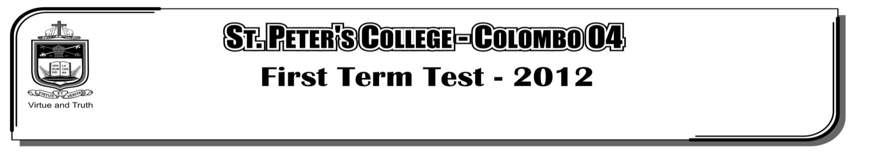

**FIRST TERM TEST - 2019**

**GRADE 11 – Western Music I**

Underline the more correct answer.

01. A standard way of connecting several keyboards known as,

i. Sequence ii. Remix iii. MIDI iv. DJ Music

02. Which of the following song is in Ternary form.

i. Sandman ii. Ashgrove iii. Minuet by Bach iv. Fur Elize

03. Which of the following music is in half the value of ${}_{2}^{2}{}$

i. ${}_{4}^{2}{}$ ii. iii. iv.

04. Another name for Ad Libitum is,

i. A Piacere ii. Cantando iii. Piumosso iv. Pizzicato

05. Which of the following is a Major triad.

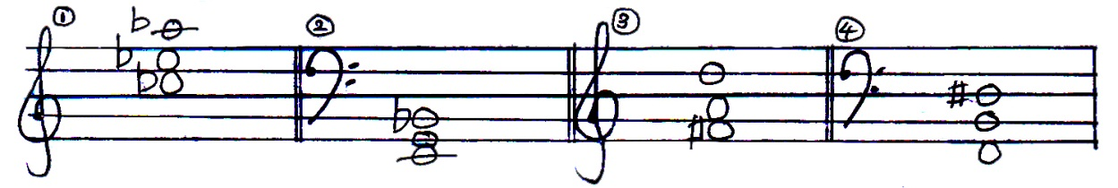

06. Which of the following terms indicate a five member ensemble ?

i. Piano quintet ii. Windquartet iii. Stringtrio iv. Clarinet Sextet

07. Which of the following has the privilege of sounding the tuning note in the orchestra ?

i. Flute ii. Violin iii. Piano iv. Oboe

08. A popular plucked string instrument used for Negro folk tunes is,

i. Banjo ii. Mandolin iii. Esraj iv. Guitar

09. Which of the following are usually written in G clef.

i. Soprano and Tenor ii. Bass and Tenor iii. Alto and soprano iv. Alto and Tenor

10. Which of the following is the opposite meaning of sonata.

i. Concerto ii. Cantata iii. Oratorio iv. Opera

11. Another name for Dixieland Jazz would be,

i. Bebop ii. New Orleans jazz iii. Blues iv. Cool Jazz

12. “Improvisation” of Jazz is,

i. Creating music on the spot ii. Accompanying the music

iii. Repeating music on the spot iv. Playing chords to the music

13. Free Jazz developed in,

i. 1950 and 60s ii. 1920

iii. The Jazzage iv. Swing era

14. Over-dubbing is,

i. Adding tracks over the top of other tracks

ii. Speeding up with drum machine

iii. Change the other tracks

iv. Combine different tracks.

15. Disc Jokey does,

i. Remixing ii. Rapping iii. Dubbing iv. All of these

16. Which of the following electronic equipment that could record, edit and replay music.

i. Synthesizer ii. Sequencer iii. Sampler iv. Keyboard

17. Which of the following device is not used in electronic music

i. Digital keyboard ii. Upright Piano

iii. Computer software iv. Synthesizer

18. Which of the following is a tone above E sharp?

i. F sharp ii. E flat iii. F double sharp iv. F double flat

19. Which of the following is a North Indian Musical Instrument ?

i. Veena ii. Sitar iii. Maddalaya iv. Esraj

20. Which of the following is a false statement for Nurthi ?

i. Songs are of North Indian Origin

ii. Tabla is the main accompanying instrument

iii. Nurthi dramas were performed in open air place

iv. The song ‘Sriya manamath wee’ belongs to Ramayana Nurthi

21. The 2nd movement of a sonata is,

i. Slow ii. Fast iii. Dance iv. Coda

22. The relative minor of the major scale consisting of 4 sharps

i. G minor ii. E minor iii. C minor iv. C# minor

23. The composer belonging to the late Romantic period is,

i. Wagner ii. Britten iii. Strauss iv. Ravel

24. Which of the following terms gives the opposite meaning of Arco ?

i. Leggiero ii. Pizzicato iii. Col legno iv. Up bow

25. What would be the pralltriller?

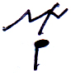C:\Users\Tania\Desktop\3.jpg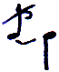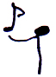

i. ii. iii. iv.

26. Which of these is not an opera ?

i. Porgy and Bess ii. Lohengrin

iii. Mount of Olives iv. Lacidorem

27. Which of the following composers were born in Russia.

i. Britten ii. Ravel iii. Debussy iv. Stravinsky

28. How many quaver pulses are there in ${}_{8}^{9}{}$ time signature.

i. 3 ii. 6 iii. 9 iv. 12

29. Which of the following describes a minuet ?

i. A French dance in triple time.

ii. A Viennese dance in three beats in a bar ?

iii. A Latin American dance in Quadruple time?

iv. A slow dance in 2 or 4 beats.

30. Which of the following is a Lied ?

i. Clair de Lune ii. Erlking iii. Bolero iv. Eroica

31. The most important instrument in a Jazz group would be,

i. Banjo ii. Trumpet iii. Guitar iv. Bassoon

32. The Modern period composer named ‘Scot Joplin’ was famous for,

i. Pop Music ii. Folk Music iii. Ragtime Music iv. Rock Music

33. Which of the following is not a Jazz composer ?

i. Charlie Parker ii. Louis Armstrong

iii. George Gershwin iv. Maurice Ravel

34. Which of the following would be the bass notes of Imperfect Cadence.

i. V – V1 ii. V – 1 iii. 1 – V iv. 1V – V

35. The drum used to accompany prashasthi is,

i. Bummadiya ii. Thabla iii. Getaberaya iv. Udekkiya

36. Which of the following would be a double reed non – transposing instrument ?

i. Double bassoon ii. Bassoon iii. Piccolo iv. Cor – Anglais

37. Which of the following is not a Musical,

i. My fair lady ii. The wizard of OZ iii. 1812 overture iv. Oklahoma

38. The section in Nadagam sung in double tempo

i. Innisaya ii. Uruttuwa iii. Dhora iv. Thanama

39. How many pedals are there in a Harp

i. 3 ii. 5 iii. 7 iv. 8

40. Which of the following composer and a pianist who made major contributions to ‘Ethnomusicology’

i. Bela Bartok ii. Stravinsky iii. Chopin iv. Liszt